ثناء محمود شناوي

Error bar

**pyplot. errorbar() Function:**

* The errorbar() function in pyplot module of matplotlib library is used to plot y versus x as lines and/or markers with attached errorbars
* matplotlib.pyplot.errorbar(x, y, yerr=None, xerr=None, fmt='', ecolor=None, elinewidth=None, capsize=None, barsabove=False, lolims=False, uplims=False, xlolims=False, xuplims=False, errorevery=1, capthick=None, *, data=None, **kwargs)
* Matplotlib line plots and bar charts can include error bars. Error bars are useful to problem solvers because error bars show the confidence or precision in a set of measurements or calculated values. Bar charts without error bars give the illusion that a measured or calculated value is known to high precision or high confidence.

* To construct a bar plot with error bars, first import Matplotlib. If using a Jupyter notebook, include the line %matplotlib inline

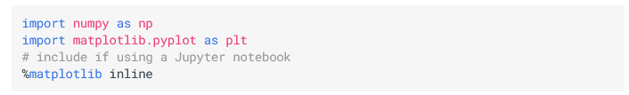

* We'll apply error bars to the Coefficient of Thermal Expansion data used in a previous section. First the data is stored in three NumPy arrays. Then the mean or average of each array is calculated. The mean of each array will be the height of the bars in the bar plot. Next, the standard deviation of each array is calculated. The standard deviation will be the height of the error bars. Finally, a couple lists are created that correspond to the bar labels (labels), bar positions (x_pos), bar heights (CTEs), and the error bar heights (error).

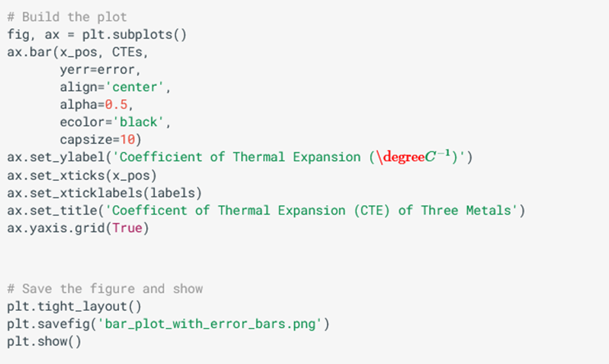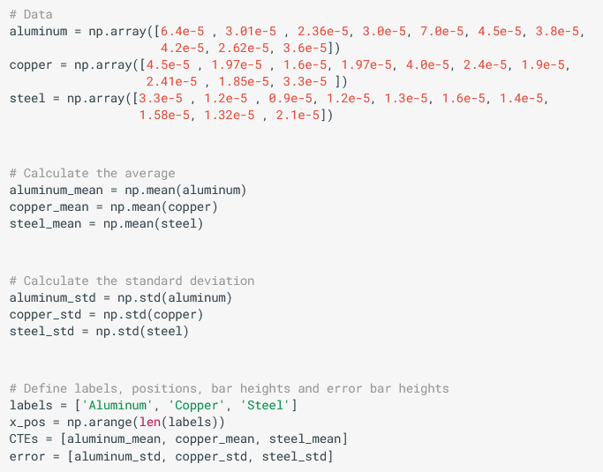

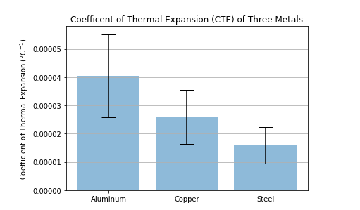

* + The resulting plot contains three error bars. We can see the standard deviation of the aluminum data is greater than the standard deviation of the steel by looking at the error by lengths.